Mary Gillett Print Workshops
September 2016 – August 2017.
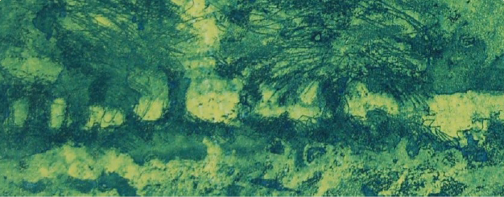

Hello everyone,
Here is a list of the courses and workshops that will take place at Tamar Print Workshop between now and next August. You'll see that I'm running a collagraph and carborundum weekend in March and a monoprint workshop in April. There will also be another five day colour course in June and the annual summer workshop in August. Where there is no medium stipulated on my list you can work with the technique of your choice. I'm following a similar date pattern to the last year because it is working very well. Student numbers are burgeoning making for a rich and vibrant atmosphere. We have lots of laughs, sometimes almost tears, and then laughs again (all the louder) when things go right - which they always do!
So come along, discover your potential and develop your skills whether you're a beginner, an intermediate, or very advanced. No matter your level or experience you will feel at home here. Feel free to get in touch and ask anything you need to know. Click here for some brief descriptions
of the range of techniques that I offer.
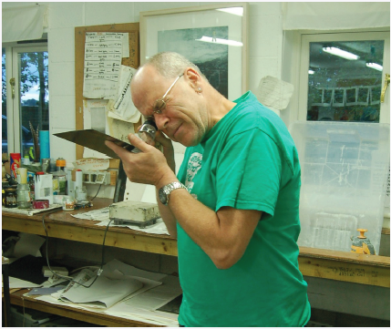
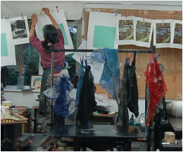
e Tweet Pin in
22nd and 23rd October 2016  choose your medium or continue with personal project | 13th and 14th May 2017  choose your medium or continue with personal project
21st and 22nd January 2017  choose your medium or continue with personal project | 17th and 18th June 2017  choose your medium or continue with personal project
18th and 19th March 2017  collagraph and carborundum | 15th to 19th July 2017  colour workshop
22nd and 23rd April 2017  monoprint and monotype | 7th - 11th August 2017  annual summer workshop
Click here for more details
You will find information about my weekly classes here. I'm afraid there is a waiting list for these
sessions but it is definitely worth getting in touch because often spaces crop up unexpectedly.
I'll leave you with one of my evening class students examining his aquatinted plate with a
magnifying lens. This might lead you to believe that etching is an exact science. Why don't you
come and find out if this is so or not?!
All the best,
Mary
www.marygillett.co.uk
©2016 Mary Gillett | Tavistock, Devon

